**ADDING LOAD IN JMETER**

Step1: Open Jmeter

Step2: Right click on Test Plan -> Click on Thread(Users) -> Thread Group

Step3: On Thread Group, Give the number of users as 100, Ramp-up period as 100, Number of iterations as 10 and save it

Step4: Right click on Thread Group -> Sampler -> Add Http Request

Step5: On Http request, give the name to it, Give the url of website we want to test in “Server name or IP” section and put “/” in Path and save it

Step6: Right click on Thread Group -> Add -> Listeners -> View Results Tree (to see the output) as shown below:

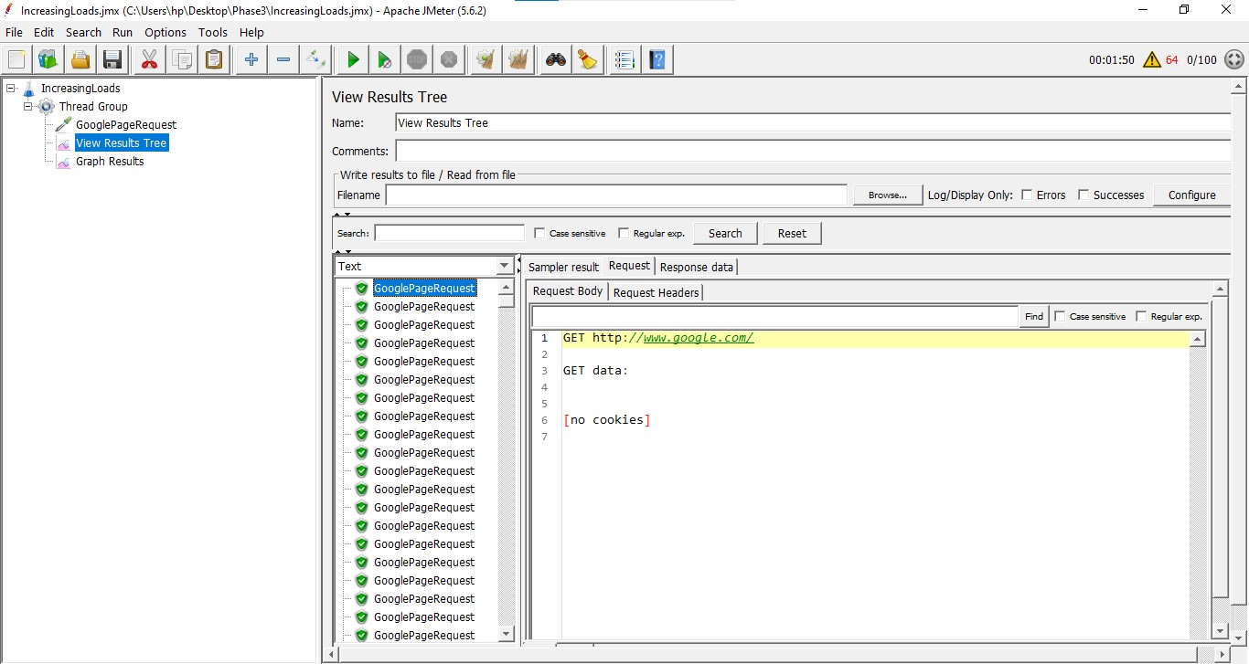

Step7: Now, to see the output in Graphical form, Add another listener -> Right Click on Thread Group ->

Add -> Listeners -> Graph results -> Save it and execute which is shown as below

